Bioinformatics Application Note:

Phylogenomics Dataset Browser

Abstract
Summary. The Phylogenomics Dataset Browser consists of a Java API and an executable binary jarfile with graphical user interface (GUI) for the high-throughput analysis of phylogenomic datasets to detect convergent molecular evolution.

Motivation. Comparative genomics studies have become increasingly common, but these analyses are sensitive to the quality and heterogeneity of input datasets (multiple sequence analyses and phylogenies). Currently few tools exist to readily compute descriptive statistics, or to visualise large numbers of input datasets. The Phylogenomics Dataset Browser facilitates these analyses in a lightweight application which allows any user to rapidly visualise, inspect, score, and sort input datasets to identify outlying datasets which may need additional processing or filtering.

Results. The application has been successfully implemented on a variety of infrastructures. A variety of common input data formats including FASTA, Phylip/PAML, Nexus, and Newick conventions are automatically read and parsed.

Availability and implementation. The API is implemented in native Java code, available online at []. The executable binary can be downloaded at []

Contact. joe@kitson-consulting.co.uk

Introduction

Features and implementation
The API elements contain resources for phylogenomics such as input/output and parsing utilities; trimming, pruning and validation methods for alignments and phylogenies; statistics for evaluating alignments, phylogenies, likelihood fits and dN/dS values; UI elements including two main GUI platforms; post-processing including linear regression and descriptive parametric statistics on large distributions of small floating-point numbers.

Evaluation
In operation, the Phylogenomic Dataset Browser was able to display up to XXX alignments of YYY taxa and ZZZ sites on a SSS system with RRR RAM requirements. Example usage statistics shown in Table 1.

Acknowledgements
This work has been funded by BBSRC at QMUL, specifically the methodological innovations for convergence detection methods correctly controlling for false positives (essential in genomic datasets) and a core API to implement these and facilitate handling genomic sequence data, carried out principally by Dr. Parker (with input from Prof. Rossiter (PI), Drs. James Cotton & Elia Stupka (Co-I) and Dr. Tsagkogeorga (PDRA)) under BBSRC # BB/H017178/1.

Figures / data / tables
Table 1: Example system resource usage. The RAM usage (in megabytes) and average load time of the Phylogenomic Dataset Browser under a variety of test computer architectures and input datasets.

Test case | Mac OSX 10.9, 2.2GHz core i7, 8Gb 1333MHz DDR3 RAM, 250 Gb SSD. | Ubuntu 14.04, CPU, RAM, Memory | CentOS cluster version CPU, RAM, Memory | Windows 7, CPU, RAM, Memory | Windows XP SP3, CPU, RAM, Memory
692 Nucleotide alignments, 7 taxa, XXX-XXX (mean XXX) nt
2,326 Nucleotide alignments, 22 taxa, XXX-XXX (mean XXX) nt
392 Nucleotide alignments, 7 taxa, XXX-XXX (mean XXX) nt
10 phylogenies, XXX taxa
1000 phylogenies, XXX taxa
Table 1

Figure 1: Phylogenomic Dataset Browser schematic. The schematic logic flow of the phylogenomic dataset browser is shown with descriptions of key analysis steps, in flow diagram format.

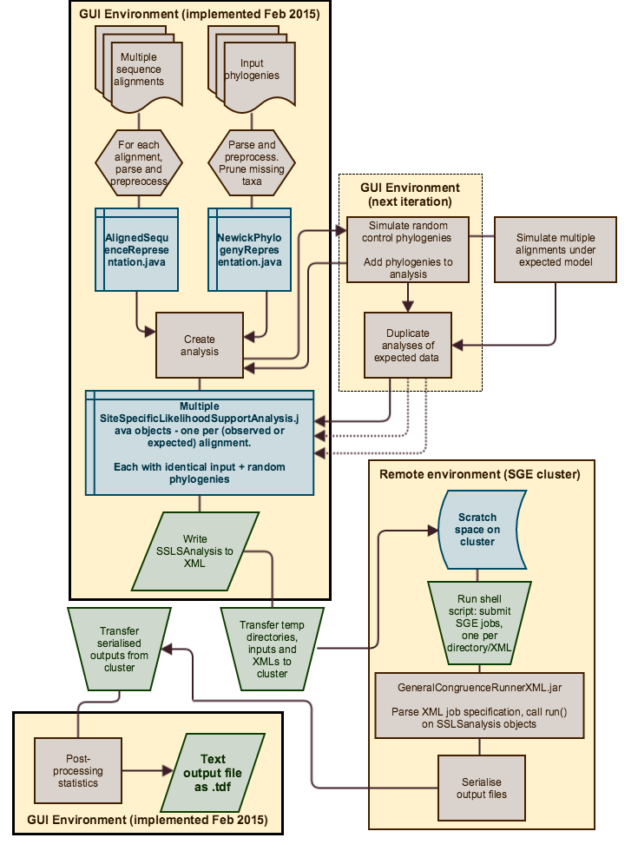

Figure 2: Screenshots showing visualisation of example datasets: (a) The alignment input screen, showing 692 multiple sequence alignments together with statistics; (b) The phylogeny input screen, showing phylogenies with graphical phylogeny display.

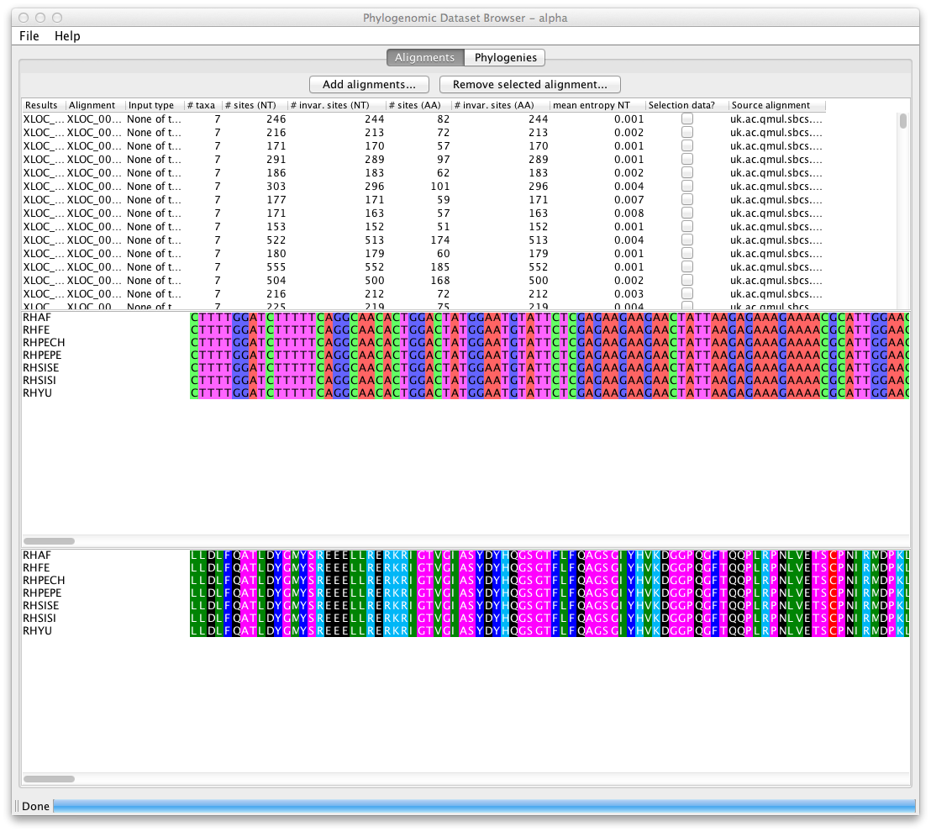
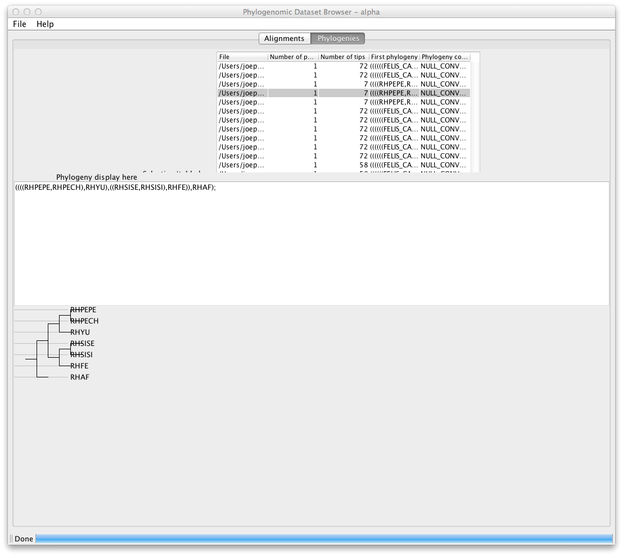

Footnotes

References

